Name ___________________________________________________________________ HR _____ Sec _____
Social Studies State Testing Dates ________________________________________________
Grade 4 Social Studies Review Packet
Geography – Relative Location
Relative location – the location of a place relative to other places

Physical characteristics – are natural parts of the land, like rivers, lakes or mountains

Human characteristics – things that people have added to a place, like a town, road or school It includes boundaries, such as city & state borders.
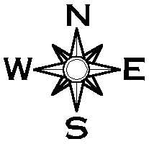
Ex: Cleveland is located south of Lake Erie. (P=Lake Erie H=Cleveland)

Cardinal directions – four main points of the compass – north, south, east and west (N, S, E, W)
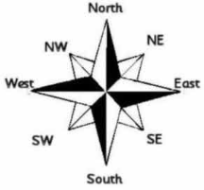
Intermediate directions – points of the compass that fall between the cardinal directions: northeast (NE), northwest (NW), southeast (SE), southwest (SW)

Compass rose – map tool that helps you determine cardinal and intermediate directions
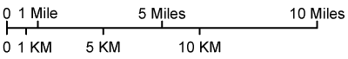
Map scale – shows relationship between units of length on a map

Geography – U.S. and Ohio: Economic Influences
Natural resources – forests, fertile soil, coal, waterways

Ex: forests = Provides building materials for homes/businesses and paper.
farms and Lake Erie = provides continuous supply of food
coal = Provides power for factories producing goods; power for ships & trains that carry goods.
waterways = Provides transportation along Ohio River and Lake Erie.
(Centrally located for northeastern states and western states to get products to market.)
Provides water source and transportation for industries near waterways.
Provides recreational opportunities for today.

**The Ohio River serviced national and international markets by the way of the Mississippi River.

Agriculture – corn, wheat and soybeans
Today, corn is used to make ethanol, a bio-fuel, and added to gasoline to reduce carbon emissions into the atmosphere. It reduces the need for fossil fuels, like coal & oil.

Industry – Coal was mined to power factories that produced goods.
Iron ore was mined to make steel tools, machines and buildings.
Alternative energy source –
A source of energy that can replace or supplement fossil-fuels like coal, oil, and natural gas.
Ex: Ohio is the leader in wind, solar, and bio-fuel energy.
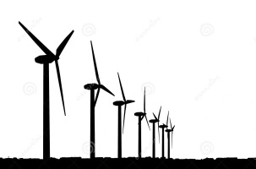
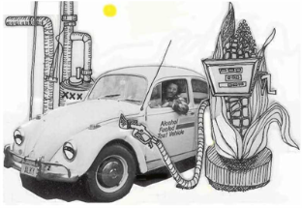

Geography – Developing Regions: North, South and West
North – rocky, thin soil not good for growing crops…used for industry
(trees for lumber and sawmills; waterways for logging, fishing & industries;
ironworks to make tools and other metal goods; textile mills for clothing)

South – cotton production in rural areas (country) with few large cities and towns
longer growing season and fertile soil to grow cotton, tobacco and sugar.

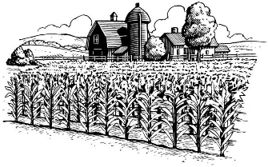
West = agriculture (land between Appalachian Mountains and Mississippi River)
including Ohio…Rich soil for farming and abundant natural resources.
Since farmland was inexpensive, many settlers moved west to start new
lives. Farmers grew wheat, potatoes and corn.
They also raised livestock including cattle, sheep and pigs.

** These three regions developed because of common physical environments and economics.
Physical environment = climate, soil, water supply, plants and animals in an area
Economics = money and resources in a region and how they are used by producers and consumers

Geography – Environment
**People modify (or change) the environment to meet their needs.
**American Indians dug quarries to excavate (dig out) flint they used to make tools and weapons.
**In the 1800’s, Ohio’s population began to grow because settlers moved west.
These settlers changed the land that was once forests, prairies and wetlands to meet their needs.

Positive and negative consequences of changes to the environment:
- People cleared land for farms and to grow crops
- People built homes for shelter
- People built roads to travel more easily
- People built railroads to travel and trade more easily
- People built dams to control water flow and flooding
- People built parks so we have a place for recreation
- People built highways and airports so people can travel to distant locations
Negative = These changes can harm the environment by destroying our natural resources,
plants, animal habitats, our wetlands and creates pollution to our environment

Geography – Railroads and Westward Expansion
**Railroads were very important in development of transportation routes.
They added westward expansion because it made travel faster and more affordable. They could carry more cargo and people.

**Railroads could not be built on wetlands, so new settlers drained and cleared more
wetlands so they could use them for farms and homes.

Geography – Chemical Modifications to the Environment
**People modify the environment when they use chemicals like fertilizers, herbicides and pesticides. They can have positive and negative consequences.
- Fertilizers promote plant growth. People use them to make their grass grow faster and thicker. Farmers use them to help crops grow faster and larger.
- Herbicides kill plants or stop plant growth. People use them to get rid of weeds.
- Pesticides kill animals or stop them from reproducing.
People use them to get rid of insects like roaches and fleas.
They are also used to control or eliminate bugs that damage crops.
**These chemicals provide positive consequences. However, they can have negative consequences. Chemicals can seep into the groundwater and rain can wash them across
the land and into lakes and streams. Chemicals pollute water and contaminate plants
and fish in the water. Humans and birds can become sick when they eat contaminated fish.

**Pollution we create today will harm future generations. We have a responsibility to use resources and make decisions wisely for the common good. Resources should be used in ways that are sustainable (able to continue over time without using up or destroying resources).
- We can buy products that are made from recyclable materials.
- We can recycle items like water bottles, newspaper, aluminum cans, etc.
- We can buy products that use minimal packaging material that we throw away.

Modification | Positive Consequences | Negative Consequences
Construction of farms, towns, roads and dams | People meet their basic needs; increase buying and selling of goods | Loss of wildlife habitats
Use of fertilizers, herbicides and pesticides | Better growth and protection of crops | Land and water pollution
Destruction of wetlands and forests | Wood is used for building and producing paper products | Loss of wildlife habitats;  increase risk of flooding

Geography – Population Growth and Cultural Diversity
When Ohio became a state in 1803, the population grew when many settlers moved to the area.
Many factors contributed to Ohio’s population in the 1800’s.
- Overcrowding and dissatisfaction with their life in the East.
Opportunity and hope to their life in the West made people migrate west.
- Ohio was centrally located and was a gateway for settlers moving west.
- Ohio settlers sent news to their friends in the east and overseas.
They told them of the availability of jobs building railroads and canals.
- In 1860, Ohio’s population was 14 percent foreign born (born in another country).
- The largest group of immigrants (person who moves from one country to another to live in another country) were from Germany, Ireland and Britain

In the 1900’s, industrialization was changing where and how people lived in Ohio.
People were moving away from small farms to take jobs in factories.
Technology innovations helped industry grow as products, manufacturing and transportation systems improved.
As a result of increased immigration, Ohio and the U.S. became more culturally diverse
(a variety of cultures in an area).

Geography – Ohio’s Location and Transportation Systems
Ohio was between the Northeast and the unsettled land to the west.
It became known as the gateway to the West.

The Ohio River served as Ohio’s main way to transport farmers and manufacturers goods to the Mississippi River. From there, goods moved to the Gulf of Mexico.
Later, roads, canals and railroads were constructed to meet the needs of the growing state and nation.
- Roads = Muddy trails were replaced with plank roads or lined with small stones.
The National Road stretched across Ohio to promote settlement to the West. It began in Cumberland, Maryland and headed west crossing the Appalachian Mountains.
It influenced movement of people, products and ideas by:

- Developing new businesses along the route allowing easier,
faster and cheaper movement of products from East to West.
- Delivering news and mail to settlers in the West was faster.
- Reduced travel time it took people to get to the West.
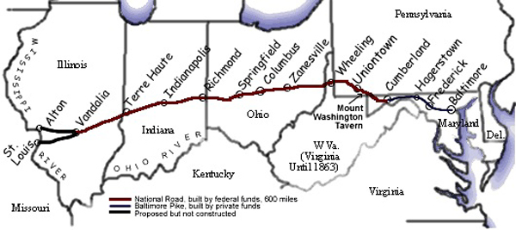

- Canals = The Ohio River only provided routes along the eastern and southern parts of Ohio. They looked at ways to make trade and travel easier. They chose a system of canals. The
first canal (large, deep trench filled with water) in Ohio was the Ohio and Erie Canal
because it connected Portsmouth on the Ohio River to Cleveland on Lake Erie.
Next, they built the Miami and Erie Canal connecting Cincinnati and Toledo.
- Provided an inexpensive way to move people and products.
- Horses and mules pulled boats along the canals.
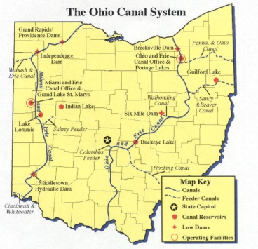
Canals gave Ohio water access to the Atlantic Ocean through the Great Lakes and to the Gulf of Mexico through the Ohio and Mississippi River.
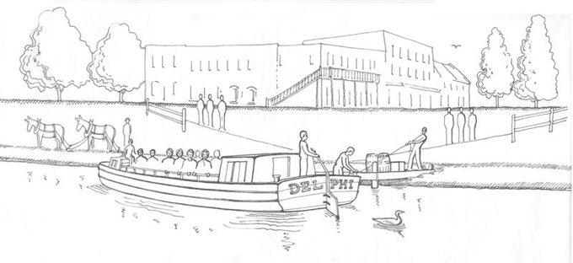

- Railroads = Before the1850’s, canals took care of much of Ohio’s transportation needs. Residents began to call for the construction of railroads began to help move people and products. Most railroads ran within the state of Ohio and barely crossed state borders.

- They provided a faster and cheaper route to places even further west.
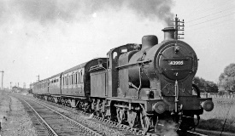
- By the 1900’s, almost 10,000 miles of railroad track crossed Ohio.

Early Railroads
Railroad | Contribution
Erie & Kalamazoo Railroad | First to operate west of Alleghany
Baltimore & Ohio Railroad  (B & O Railroad) | Crossed the Appalachian Mountains to East
Ohio and Mississippi Railroad | Faster and cheaper to West to Missouri

Ohio continues to be a busy transportation hub for the nation because
of its location and its major transportation systems.

Ohio is centrally located between two major industrial and consumer markets—
the Northeast and the Midwest. Within 600 miles of Ohio’s borders lie:

- Over 60% of the U.S. population
- Over 60% of all U.S. manufacturing facilities
- Over 50% of all Canadian manufacturing facilities

Ohio’s location makes it an ideal place to influence the movement of people,
products and ideas throughout the U.S. and the world.
HISTORY – Timelines
A timeline is a useful tool showing events in chronological order (order in which they occur).
Always read the title to know what the topic is.

Timeline title examples:

Ohio’s March to Statehood
Ohio becomes 17th state
in 1803
People in Ohio Territory draw up state constitution in 1802
Britain give Northwest Territory to U,S. in 1783

Events Leading to the Civil War
John Brown raids
Harpers Ferry in 1859
Battle at Fort Sumter
begins in 1861
Uncle Tom’s Cabin
published in 1852

Famous Ohio Inventions
Thomas Edison invents the phonograph in 1877
Garrett Morgan invents
traffic signal in 1923
Orville & Wilbur Wright fly
first airplane in 1903

Timeline intervals are the defined time periods marked off by two points.

1880
1860
1840

1870
1876 telephone invented
1852 passenger elevator invented
1850
1844 Telegraph Invented
1879 incandescent light bulb invented

Interval: 10 years

HISTORY – Primary & Secondary Sources

Primary sources are the original records of a past event, usually created by someone who
actually saw or participated in an event. Objects created or used in the past are called
artifacts (an object made or used by humans long ago), are also called primary sources.

- photographs 6. official documents
- video recordings 7. original artwork
- memoirs 8. posters
- interviews 9. advertisements
- artifacts 10. films created around the time of the event

Secondary sources are records of an event written or told by someone who was NOT actually there. They are recorded AFTER events have taken place. Secondary sources usually summarize, restate or analyze information from one or more primary sources.

- news article
- textbooks
- encyclopedias
- books
- articles

Primary and secondary sources are historical narratives (information about the past event is retold as a story).
The purpose of a historical narrative is best described as informative.

Primary source = original and direct information
Secondary source = indirect and summarized information

Examples:

Primary Source | Secondary Source
Personal diary of Thomas Jefferson | Internet article about the culture of American Indian tribes
Grandmother’s wedding dress | Encyclopedia article about famous Ohioan inventors
United States Constitution | Book about flags that were carried  by soldiers in the Civil War
Flag that was carried by a soldier
in the Civil War
An audio recording of Martin Luther King, Jr.’s “I Have a Dream” speech

HISTORY – Cooperation and Conflict
Cooperation = people or groups working together to achieve a common goal or benefit
Conflict = struggle clash, or battle between opposing people or groups

Cooperation occurs when the goals of two people or groups are seen as mutually beneficial.
They work together.

Factors that lead to cooperation include:

*A shared or similar goal *Abundant resources to share

*Flexibility to change or adapt behaviors *Tolerance to accept beliefs or
customs of other people

Factors that lead to conflict include:

*Different or opposing goals *Scarcity of resources

*Rigidness or willingness to accept *Intolerance to accept differing beliefs
interference or customs

HISTORY – Prehistoric American Indians of Ohio

Prehistoric – related to the period of time before written records

Paleo
Archaic
Woodland (Adena & Hopewell)
Late Prehistoric (Fort Ancient)

Historic Indians = Delaware, Miami, Ottawa, Seneca, Shawnee and Wyandot

Paleo Indians – first Indians to arrive in Ohio. They hunted animals like the mammoth and
sabre-tooth tiger. They lived in small camps and moved around following animals to hunt.

Archaic Indians – Lived by hunting, fishing and gathering plant foods. They created tools for
hunting like axes and weighted spears.

Woodland Indians – hunted and gathered, but also began to farm. They became known as the mound builders.
- The Adena culture built basic mounds to bury their dead leaders.
- The Hopewell expanded the burial mounds into earthworks. They were used for
burial mounds and religious ceremonies.

Late Prehistoric Indians – constructed complex villages near waterways and fertile soil.
They built wooden fences around their community for protection.
They farmed, hunted, fished and gathered food.
*The Fort Ancient culture is an example.

Cooperation ~ The mounds were large and complex and took many people working together to build. They also traded with one another.

Conflict ~ Many Late Prehistoric Indian groups wanted access to good hunting territory and
control over good farming land that caused conflict between them.

Historic Indians of Ohio ~

- Delaware Indians ~ Originally lived along Delaware River in New Jersey. Moved west due to European colonists overtaking land and battles with Iroquois Indians.

- Miami Indians ~ Originally lived in Indiana, Illinois and Michigan.
Moved into Ohio around 1700 and became the most powerful tribe in the state.

- Ottawa Indians ~ Originally lived in Canada and moved into Ohio around 1740.

- Seneca Indians ~ Originally from New York. They are also known as the Mingo Indians.

- Shawnee Indians ~ Lived in the Ohio River Valley in the late 1600’s, were driven away by the Iroquois and then moved back.

- Wyandot Indians ~ Originally lived in Canada and known as the Huron Indians. The Iroquois drove them into Ohio.

Immigrants & Migration

migrate = to move from one region and state and settle in another
immigrants = people who move to a foreign country to permanently settle there

Many settlers migrated to Ohio from the Mid-Atlantic states, particularly Pennsylvania.
A large number of migrants were of German and Scottish-Irish heritage.

Immigrants came from many countries. The largest numbers came from Germany and Ireland. They wanted a new life and land for farming.
They worked together to create new settlements building homes, schools and churches.
They cooperated to build transportation systems like canals, railroads and businesses.

As Europeans arrived, they interacted more with the Indians. They traded, shared
knowledge, farming and growing crops and ways to hunt animals.

Conflicts arose over use and ownership of land between the two groups.
The Indians believed “everyone” owned the land, not one specific person.
The Europeans saw the land as “private property” and legally owned by an individual.

American Indians only killed animals needed for food, shelter or clothing.
The Europeans killed more than they needed and did not use all the body parts of the animal.
HISTORY – Conflicts that lead to war
In the mid 1700’s, Britain and France wanted to control the Ohio River Valley.
Each wanted the land because:

- It was good for growing crops and abundant animals for hunting.
- This land would also help them expand their territory into North America,

These conflicts lead to war. Many Indians sided with France because the French traded with them. This became known as the French and Indian War. It lasted from 1754 – 1763.

France lost the war. France had to give up its territory between the Appalachian Mountains
and the Mississippi River to Britain.

After the war, the British soldiers stayed in the Ohio River Valley.
This lead to more conflict because the Indians there did not like the British living there.
Pontiac led a rebellion against the British, but he was defeated.

To avoid more conflicts with the Indians, the British king passed a law called the Proclamation of 1763.
Proclamation of 1763 allowed Indians rights to lands just won from France.
It also forbid (did not allow) colonists from settling west of the Appalachian Mountains.

HISTORY – New Nation
Taxes = money collected from citizens and businesses to pay for services provided by the
government.

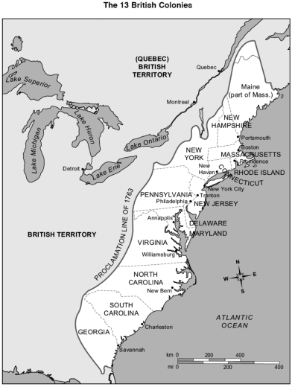
boycott = refuse to buy goods as a protest against something

After the French and Indian War, Great Britain wanted to gain more control.
They placed several taxes on sugar, stamps, paint and tea.

Proclamation of 1763 – set aside land west of the Appalachian Mountains
for American Indians. It prohibited colonists from settling on the land.

The French and Indian War was expensive for Great Britain.
They decided to tax the colonists:

1. Sugar Act of 1764 – pay tax on sugar, molasses and several other goods.
2. Stamp Act of 1765 ~ required to buy a government stamp for every paper document
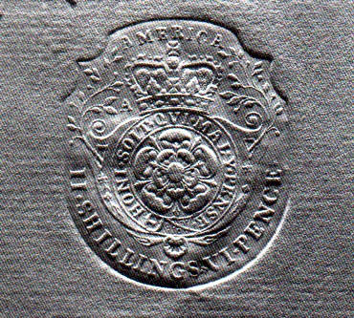
(newspapers, legal documents and playing cards)

They decided to boycott British goods.

In 1773, the Tea Act allowed British to sell tea cheap. The colonist had to pay the tea tax.
On December 16, 1773, 300 chests of British tea were thrown into the Boston Harbor.
The “Boston Tea Party” made England’s King George III upset.
The Boston Harbor was closed until colonists paid for destroyed tea.
They saw King George III as a tyrant (cruel and unreasonable ruler).
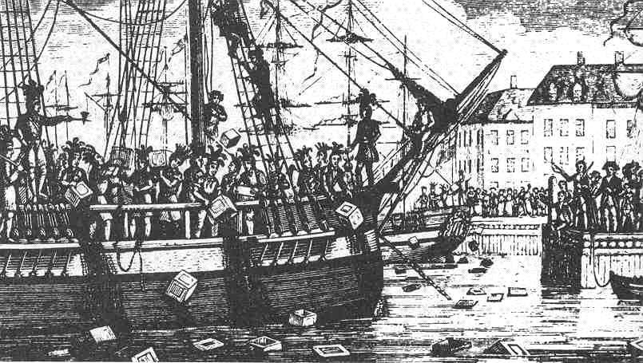

HISTORY – Declaration of Independence

The colonists wanted to be free. They wanted their own government and to make their
own laws and be free from British control. April 19, 1774, the first battle between British
soldiers and American colonists to place at Lexington and Concord Massachusetts, known
as the American Revolution.

American Revolution:
1. Gained independence from Great Britain
2. U.S. gained land from Appalachian Mountains to the Mississippi River

Thomas Jefferson and several other delegates approved the Declaration of Independence
on July 4, 1776. It listed colonists’ complaints against King George III and their decision to
free themselves from Great Britain to make their own laws and taxes.

The Continental Congress appointed George Washington to lead the American Army
against the British. The soldiers were made of untrained volunteers. They did not have many supplies or uniforms.

After many years of fighting, the British surrendered at the Battle of Yorktown in 1781.
In 1783, The Treaty of Paris ended the American Revolutionary War. They succeeded to gain their independence from Great Britain. Land was gained west of the Appalachian Mountains all the way to the Mississippi River—including Ohio.

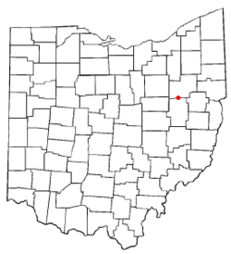
Fort Laurens was built in 1778 to protect settlers from Indian raids.
Ft. Laurens was the only fort built in Ohio during the American Revolution since no major battles were fought in Ohio.

HISTORY – Articles of Confederation
The colonists formed a new government under the Articles of Confederation in 1781.
It was the first written Constitution of the United States.
They were afraid to give their government too much power. Their document was weak.
It allowed the U.S. government to declare war and sign treaties.

HISTORY – The U.S. Constitution

constitution = a document that describes the system of government and founding principles
of a state, nation or organization.

amendment = a change or addition to a written document

The government needed a stronger government so in May 1787, delegates from
12 states met in Philadelphia to write a new constitution.

- The U.S. constitution allowed the states to elect representatives to a two-house congress.
- It established the office of the President.
- The U.S. government could tax the states.
- It allowed changes, or amendments, to be made to it.

HISTORY – The Bill of Rights

In 1791, the first ten amendments called the Bill of Rights were added to the Constitution.
The Bill of Rights protects individual rights that include:

- Freedom of Speech
- Freedom of Religion
- Freedom of Freedom to a fair trial by jury
- Right to bear arms
- No cruel or unusual punishment

Freedom of Religion, Freedom of Speech, Freedom of Press,
Right to Petition and Freedom of Assembly

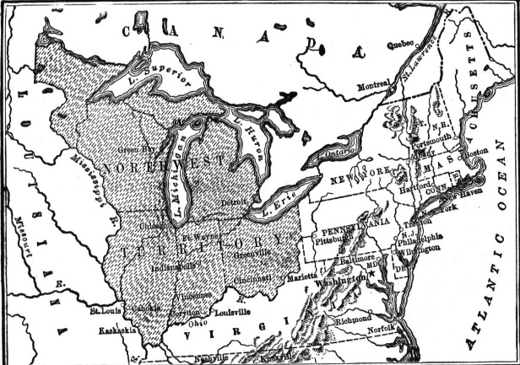

HISTORY – The Northwest Ordinance

In 1783, the defeated British gave the Northwest Territory to the United States as part of the treaty signed at the end of the Revolutionary War.

It included land south of the Great Lakes, north and west of the Ohio River and east of the Mississippi River.

In 1787, Congress passes the Northwest Ordinance. This allowed Congress to divide the Northwest Territory into three to five separate territories. It established governments for
each territory and how these territories could become states.

Steps to Statehood:

- Congress would appoint a group of leaders to govern people in the territory.
The leaders would include a governor, secretary and three judges.

- When the population reached a minimum of 5,000 free adult males, residents
could elect political leaders to govern them.

- Once 60,000 free people (male & female) reside in a territory, the territory could apply
for statehood. The residents could hold a constitutional convention, draft a state constitution, and submit the document to the U.S. Congress for approval.

Democratic ideals = beliefs that support democracy, such as freedom, justice and equality. Everyone has a say in how they are governed.

It was common for a government to give land to soldiers for two reasons:

- urge them to join the military
- compensation for the hardships they endured during the war

To pay back veterans of the Revolutionary War, the U.S. government set aside a large
piece of land in the Northwest Territory.

HISTORY – The Northwest Ordinance

American Indians – had fought to protect the territory from earlier settlers, wanted to
keep the right to live and hunt there.

American settlers – saw the new territory as part of the U.S. and wanted to build a new
life, homes and businesses there.

British – wanted to keep their profitable fur trade and protect their land in Canada.

HISTORY – Western Confederacy

coalition = a partnership or alliance for a specific purpose

raid = a surprise attack by a small armed force

In 1786, Indian tribes in Ohio and Illinois formed a coalition of tribes called the Western Confederacy. The tribes believed the U.S. did not have rights to take Indian land.

Blue Jacket and Little Turtle fought to resist settlers moving into the Ohio valley.
They raided American settlements. The British forts in Canada supplied weapons to the Western Confederacy to help them fight against the American settlers.

President George Washington asked General “Mad” Anthony Wayne to train an army
that could defeat the Indian tribes. In 1794, General Wayne and his troops attacked at
the Battle of Fallen Timbers. General Wayne defeated the Western Confederacy (Indians) and ended Indian raids for a while.

HISTORY – Treaty of Greenville
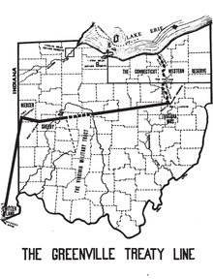
treaty = an official agreement between two groups of countries

After the defeat at the Battle of Fallen Timbers, many tribes
signed the Treaty of Greenville, giving up their claim to land in
much of Ohio. The treaty took away land in eastern and
southern Ohio and required them to move to the northwest
corner of Ohio. In exchange, the U.S. government gave the
Indians $20,000 worth of goods that included blankets and
farm animals. For every year they stayed in Northwest Ohio,
The government promised to give Indians cloth and money.
**Many tribes refused to sign the Treaty of Greenville and
continued to fight for their lands.

HISTORY – Tecumseh
confederacy = a league or alliance of states, tribes or groups

A Shawnee leader, Tecumseh, and his brother, the Prophet, tried to form a new Indian confederacy. They traveled across the Northwest Territory and persuaded Indian tribes
to unite to protect their lands.

Tecumseh and the Prophet established Prophetstown, a Shawnee town just below the Tippecanoe River near today’s Lafayette, Indiana.

In 1809, another group of American Indian tribes in Ohio signed the Treaty of Fort Wayne.
It sold 3 million acres of Indian land to the United States. Tecumseh was angry such a large area of Indian land had been lost. He warned that is any more land were taken from the Indians, there would be violence.
HISTORY – Battle of Tippecanoe
In 1812, Tecumseh traveled into Tennessee and Kentucky to ask some Indian tribes to
join their confederacy. While he was away, Governor William Henry Harrison ordered
1,000 American troops to march toward Prophetstown. The Prophet ordered the attack against the Americans which began The Battle of Tippecanoe.

The United States wanted to: | Great Britain wanted to: | American Indians wanted to:
* keep the British out of the  Northwest Territory.  * stop American Indians from  causing problems for settlers  * take control of Canadian  land | * keep its land in Canada  * continue its profitable fur  trade with American Indians  in the Northwest Territory | * stop American settlers from  taking their land  * force American settlers to  leave the Northwest  Territory  * continue trading with the  British

HISTORY – War of 1812
The United States declared war on Great Britain in 1812. General William Henry Harrison
had his troops build Fort Meigs along the Maumee River to protect their ammunition and supplies. It was a lookout for British movements into Ohio.

General Oliver Hazard Perry defeated the British navy at the Battle of Lake Erie in 1813.
The U.S. victory meant the British could no longer provide American Indians with weapons
to continue to fight.

After the battle, General Harrison confronted Tecumseh at the Battle of the Thames where Tecumseh was killed.
Event | Results | Significance for U.S.
Fort Meigs | U.S. troops defeated British and Indians in an attack on the fort | The fort gave U.S. an area to prepare for a military invasion
Battle of Lake Erie | Americans defeated a British navy | The British could no longer provide American Indians with weapons to continue fighting in the Northwest Territory
Battle of the Thames | U.S. troops won the battle. Tecumseh was killed. | Indian leadership weakened after Tecumseh’s death.

HISTORY – North vs South
slave = a person who is legally owned as property by another person

plantation = a large farm on which crops are raised to be sold

abolish = to end or prohibit by law

Most of the states in the North were considered free states, where people were not
allowed to own slaves. Workers were paid wages for their work.

The South was mainly an agricultural region. The south’s most valuable crop was cotton.
The south sold cotton, tobacco and other crops to the North and Europe. Many farms
and large plantations depended on slaves brought from Africa to plant and pick cotton
and other crops. Slaves were not paid and did not have any freedoms or rights.

Free State or Slave State

Each time a territory became a state, the North and South argued whether it should be
a free or slave state. Northern states feared slavery would spread across the U. S. and the Southern states feared if there were more free states Congress would abolish slavery.
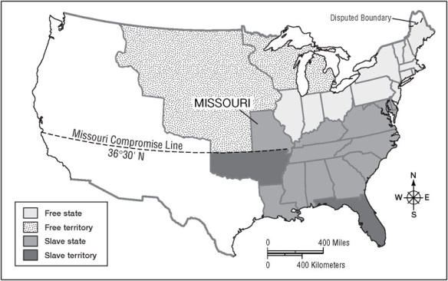

Ohio became a state in 1803 under the Northwest Ordinance.

It was admitted as a free state. Abolitionists opposed slavery and wanted to end it.
Quakers, a religious group in Ohio, were some of the first Ohioans to speak out against slavery.
HISTORY – Underground Railroad
fugitive = a person who has escaped from a place or who is hiding to avoid capture

conductors = free people who helped slaves escape

Many slaves used the Underground Railroad (secret routes) to help fugitive slaves escape
to freedom. Ohio served as a “trunk line,” or main route. Conductors helped slaves escape throughout Ohio with safe houses where slaves were hidden during the day. At night, they traveled to the next station of the Underground Railroad.
Slave owners paid slave-catchers to capture slaves. The Fugitive Slave Act of 1850
allowed slave-catchers to enter the North to capture fugitive slaves. It made it illegal to
help escaped slaves. Anyone caught would be fined and placed in prison. Runaway
slaves were no longer safe, even in free states. To be safe, they needed to travel all the
way to Canada.

Many Ohioan abolitionists continued to help slaves, including famous John Rankin.
More than 2,000 slaves cross the Ohio River to find shelter at his home.

Other important abolitionists, Levi Coffin and John Parker played important roles in the Underground Railroad.

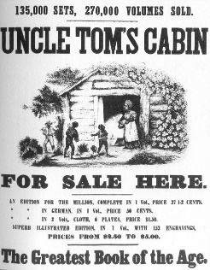

In 1852, Harriet Beecher Stowe wrote Uncle Tom’s Cabin, which
told a story about the treatment of slaves. It was based on interviews
she had with slaves. This book influenced Ohioans to support the
abolitionists movement, that would eventually led to the Civil War.

GOVERNMENT – Constitution
rights = freedoms that are protected

representative = a person chosen to speak or make decisions for another person or
group of people

The constitution is a written plan for the government. It describes how the power if divided. Each state has a constitution.

The Ohio Consititution and the U.S. Constitution limit the powers of government by:

- separate power into different parts of the government
- describe what the government may and may not do
- define the authority of elected officials
- protect the rights of citizens

The Articles of Confederation was the first written plan for the U.S. government.

In 1776, American colonists declared independence from Great Britain. They drafted
the Articles of Confederation. However, they felt it was a weak national government
that was not strong enough. They did not want to be ruled by another government
that might take away their rights.

In 1787, the U.S. Constitution was written to create a stronger government.
It is still a plan we use today.

- People are the source of government’s authority
- Citizens vote to decide issues and choose representatives
- The government’s powers are limited by the U.S. Constitution
- The basic rights of citizens are protected by the U.S. Constitution

GOVERNMENT – Protecting Rights
The Bill of Rights is the first ten amendments to the U.S. Costitution. The Bill of Rights
protects our basic rights as citizens and prohibits the government from making laws
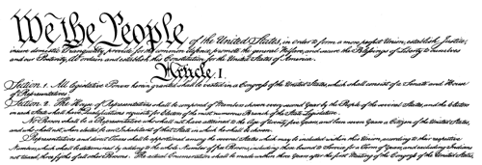
that interefer with those rights.

The First Amendement

- Freedom of Religion – practice whatever religion they want

- Freedom of Speech – right to speak their own opinions

- Freedom of Press – right to access sources of information. The government
cannot control or limit information in newspapers, tv, radio, books, or the internet.

- Right to Petition – formally ask for changes to the government.
You can join other peope by signing a formal request (petition), write a letter,
call or email your representative in Congress about laws you want passed.

- Freedom of Assembly– free to assemble (gather in groups) to worship, be with friends, enjoy recreation or to accomplish a goal.

GOVERNMENT – Three Branches of the U.S. Government
Laws are a system of rules that people in a state must obey. The government makes taws to protect the rights of citizens. The U.S. Consitution protects some of Americans’ basic rights under the First Amendment.

Legislative – writes/passes the laws for the nation.
Congress has two houses: U.S. Senate and U.S. House of Representatives

Executive – carries out and enforces he laws.
President heads the executive branch.

Judicial – interprets and applies the laws. Courts decide the meaning of the laws,
determine whether or not they are allpied correctly and whether or not laws
are being broken.
U.S. Supreme Court (highest court)
Federal courts

- No one branch of government has too much power. This is known as
“separation of power.” Each branch has the power to check, or limit,
the power of the other two branches. This is known as “checks and balances.”

 | Executive | Legislative | Judicial
Funcution | Carries out and enforces the laws | Writes and passes the laws | Interprets the laws
The people:  National | President | Congress:  *Senate  *House of  Representatives | U.S. Supremne Court
State | Governor | General Assembly:  *Senate  *House of  Representatives | Ohio General Assembly
Local | Mayor | Town Council | Mayor’s Court

Laws are beneficial to citizens because:

- Laws establish order and help keep us safe.
Traffic laws establish the rules of driving that everyone must follow.
Without traffic laws, driving would be confusing and dangerous.
- Laws protect our property.
Laws protect our land, homes, cars and personal belongings by
outlawing theft (stealing something that does not belong to you).
It is illegal to steal someone else’s property.
- Laws ensure education for all American children.
Each U.S. state is required to provide a school system for the children
in that state.
By law, children must attend school—whether public, private or home school.

GOVERNMENT – Responsibilities
Laws assign responsibility to citizens. Citizens have a responsibility to help the government function properly. When you are an adult you will have the following responsibilities:

- Paying taxes
Taxes from citizens pay for public goods such as roads, bridges and public
schools that everyone can use.
Without taxes, the government could not provide these benefits.
- Serving on a jury if called
Serving on a jury helps our judicial courts work properly.
This responsibility allows every person to have a fair trial by jury.
- Obtaining proper licenses
The government requires people to get a license in order to perform certain
activities. This often is to help keep citizens safe.
Examples:
*Obtaining a driver’s license means you are capable of driving
and you know the laws. That helps keep you and other people
on the road safe.
*Licenses for certain jobs such as: doctor, lawyer, truck driver or
construction workers.

Personal responsibilities:
- Take advantage to get an education
As you become educated you improve your career and ability to earn an income. If you become a doctor or lawyer, you improve the lives of other people.
- Using resources wisely
Recycling and returning library books are examples.
These actions help your community now and in the future.
- Using and sharing your abilities where you are needed
Your skills, experiences and knowledge allow you to be creative, inventive, organized, helpful, caring and productive.
**You use these abilities to improve your own life and lives of others.
**You help your community to speak up about problems and provide ideas
for solutions.

Civic responsibilities:

- Obey the laws
Laws establish order, keep everyone safe and protect people’s rights
and assign responsibilities.
- Pay your taxes
Taxes help pay for many of the services and benefits the government provides.
- Serve on juries
A jury is an important part of receiving a fair trial if you are accused of a crime. Serving on the jury is part of your duty as a citizen if you have been selected.
- Register for the selective service
This law is for adult men only. You must be 18 years old.
In time of war, men may be called or “drafted” to serve in the military
to protect and defend the nation.

Be an active citizen:
Get out and vote… (You must be 18 years old)
Voting allows citizens to decide issues and to select representatives.
Respresentatives may include:
president, senators, governors, mayors, police chiefs and school board members
**These government officials get their power and authority from citizens.
They help make and enforce laws that you have to live by.

- Communicate with government officials
Call, email or write letters to your representatives to voice your opinion.
- Join and participate in Civic Service Organizations
Groups that work to achieve goals
- Perform voluntary service
Volunteer for public service such as the fire department, town council,
military, school boards, etc.

Making Decisions:
Individuals must make informed and reasoned decisions you need to evaluate
the information. You get information from learning about a candidate or issue by:

TV, websites, newspapers, radio, blogs, speeches, debates,
talking to people, analyze the information and using logical
and critical thinking.

Compromise:
A compromise is a settlement of differences in which each side makes concessions (gives up some of the things they want).

**It involves taking turns, looking for common goals or principles and give and take.

ECONOMICS
Be able to read tables, charts, graphs and diagrams.

Productive Resources:
Productive resources = the resources used to make goods and services

- Natural Resources
Resources that come from nature like trees, minerals and land.
You might use iron or coal to produce steel for cars or wood from trees
- Human resources
Talents and skills of human beings to produce the goods and services.
They all come from some sort of labor.
Examples:
*A farmer workers in a field to provide fruit and vegetables for consumers.
*An architect provides labor when designing a building.
*A general contractor provides labor in the construction of a building.
- Capital goods
Human made materials needed to produce goods and services.
Capital goods include: buildings, machinery, equipment and tools.

An entrepreneur is an individual who organizes the use of productive resources
(natural, human and capital) to produce goods or services.

Entrepreneurs are willing to take risks to develop new products to start a business.

The use these productive resources to make a profit.

**Profit results from the sales of goods and services.
You must sell or produce your service for more than it costs to make it.
If a business is not able to do this, the business takes a loss.

Benefits and Risks of being an Entrepreneur…

Benefits | Risks
Being your own boss | Tough competition
Enjoyment and excitement | No regulary salary
Flexibility and freedom | Work schedule may have long hours
Profit potential | Stress of responsibilities

ECONOMICS – Managing Your Money
income = money received for work or through investments

interest = money paid for the use of someone else’s money

budget = keeping track of how much money you spend and save

trade-off = exchanging one thing for another

sacrifice = something you give up in order to do something else

The sooner you start practicing good money habits, the better off you will be later on in life. When you have income from a job, a budget is a way to keep track of how much money
you spend and how much money you save. It helps you keep a close eye on how much money you have and how you spend it.

Spending and saving decisions are important. If you don’t keep track, it’s easy to spend
too much of it. Saving money allows you to have extra cash when you need it.

You can also increase your savings when you keep it in a savings account at a bank and
earn interest on your money.

Save slow and steady. Saving money can involve some trade-offs or sacrifices.

- You can save money for an expensive item you want to buy, like a computer.
- You can save for something important, like a college education.
- You can save for a time you might need the money, like when a car needs repairs.

**Savings contribute to your financial well-being because you will
be prepared for large expenses or unexpected needs in the future.

INVENTORS Inventors not only make new things, they also improve upon devices, methods
or ideas that already exist.
Inventor | Invention | Benefit to the U.S.
Thomas Edison | Incandescent light bulb | Better than expensive oil lamps & candles, could work after dark, businesses/factories could stay open longer, people could play after dark.
Thomas Edison | Phonograph | Could stay at home, listen to concerts at home, information and entertainment was easier to get and less expensive.
Thomas Edison | Kinetoscope –  Motion picture camera and projector | Entertainment and could see movies and news events—led to movie theaters and television industries.
James Ritty | Mechanical Cash register | Helped businesses keep track of money.
Charles Kettering | Electric cash register | Helped businesses keep track of money more efficiently.
Charles Kettering | Electric starter for the automobile | Made it safe and easy to start a car, increase in car sales.
Thomas Midgley, Jr. hired by Charles Kettering to improve engine sound | Ethyl gasoline | Stopped knocking in the car’s engine—allowed them to run smoothly over long distances. It was later found to be harmful to the environment and banned in 1970. Now “unleaded” gasoline replaces it.
Garrett Morgan | 3-way traffic signal | Controlled traffic and helped avoid car accidents—looked like a T-shaped pole and showed: stop, go, and all-directional stop. It was later replaced by the red, yellow and green traffic lights we use today.
Garrett Morgan | Gas mask | Protected people from breathing smoke and other toxic chemicals.
Orville & Wilbur Wright | Motorized airplane | Designed and developed new way of travel—flying. It allows people to travel quickly to places far away.
William Semple  & Amos Tyler  (both patented it the same year) | Chewing Gum | Helped clean the teeth and strengthen jaw bone
James M. Spangler | Vacuum cleaner | Made cleaning easier.
Granville T. Woods | Automatic railroad brakes, telephone transmitter, railway telegraph,  electric egg incubator | Send and receive messages quickly to make conversation and railroad travel safer.
Charles F. Brush | City street lights | Made it easier to see during night hours

**Be able to tell if the invention is used for safety or entertainment or business.

